**KS3 – DP3 Assessment**

**Instructions- PLEASE READ**

* Make sure you have DOWNLOADED and saved this document BEFORE you edit it
* Please write your name AND the title of the investigation
* Please edit this document and type your answers under the headings provided. You can use as much space as you need.
* These are the same headings on the writing frame you have been using and the marking grid I have used to mark your work.
* Those students that are not using Microsoft Word please speak with your I.T teacher to find out how to edit this document
* YOU HAVE UP TO THE END OF THURSDAY’S LESSON (21ST MAY) TO COMPLETE THIS ASSIGNMENT.
* UPLOAD YOUR ASSESSMENT TO YOUR TEAMS CHANNEL

Full name:­­­­­­­­­­­­­­­­­­­­­ __Zein____________________________________

Investigation: _______Ice Drinks______________________________

Hypothesis

*In which type of drink will the ice cube melt the fastest?*

Prediction

I think that the cube will melt the quickest in the Coca Cola due to the density in the drink.

Variables

Dependant Variable: the time it takes for an ice cube to melt

Control Variable: The amount of liquid in a cup, size and amount of ice cubes, the temperature of the liquid, the same type of cup.

Independent Variable: The type of drink

Method

1. Collect apparatus
2. Place an ice cube in the Coca Cola, at the same time start the stop watch
3. Once invisible to the naked eye, stop the timer and record results
4. Repeat steps 2-3 for the remaining drinks

Results (table)

|  |  |
| --- | --- |
| Type of Drink | Time it takes for the ice cube to melt (min:sec) |
| Coca Cola | 37:18 |
| Orange Juice | 57:11 |
| Water | 24:47 |
| Milk | 46:08 |

Graph.

* please draw your graph and take a picture of it and paste it here
* Make sure I can read your axis CLEARLY

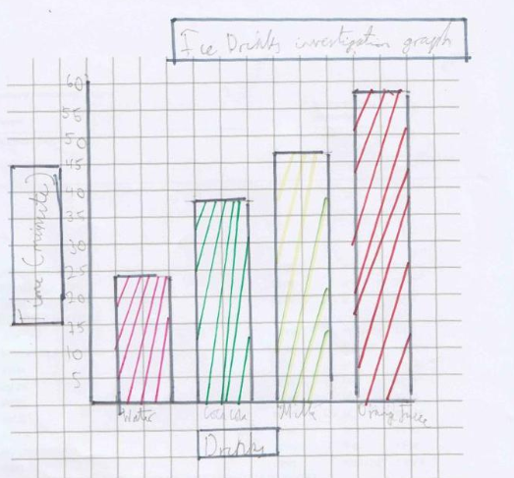

Interpreting data & Conclusion

For this experiment, the water melted the cube the fastest, this was likely because our water contains lots of solutes which speeds up the melting due to how it lowers the melting point of water. The Coca Cola would have melted faster than the water if we had water with minimum chemicals. As for the milk, it should have melted quickly due to the fact that it is also dense however it I made errors in this experiment, this is the same case with the orange juice (I also made an error with the orange juice).

To conclude, the water melted the fastest due to the solutes and chemicals this doesn’t match with the prediction which said that the Coca Cola would melt the fastest. As said already, the Coca Cola would have melted faster if we had close to distilled water (water with minimum chemicals).

Improvements

In order to keep the experiment accurate, I should have used thermometers in order to measure the temperature of the drinks in order to control the temperature better which was the reason why I got anomalies for the milk, orange juice and water. Therefore I should have left the drinks for and extended period of time (e.g. 48 hours) to really control the temperature then measure it with a thermometer to see if they are the same.